CR-05 - Goals and Outcomes
Progress the jurisdiction has made in carrying out its strategic plan and its action plan. 91.520(a)
This could be an overview that includes major initiatives and highlights that were proposed and executed throughout the program year.

The City of Texarkana, acting through its Office of Public Works and Community Development, conducted a series of public forums—both educational and technical—to empower its citizens and engage the public sector in developing a realistic response to the community’s articulated needs and priorities for fiscal year 2024. The insights gained from these meetings, along with the subsequent application process, contributed to the development of the FY25 Action Plan.
During FY2025, the City of Texarkana made significant progress in addressing the priorities, strategic objectives, and performance measures outlined in the FY25 Action Plan and the Consolidated Plan. These accomplishments are summarized across several goals and categories, including Capacity Building, Engagement of Neighborhood Stakeholders (focusing on Affordable Housing), Fostering Neighborhood Economic Development (Non-Housing Community Development), and Infrastructure Improvements (covering both Affordable Housing and Non-Housing Community Development).
Comparison of the proposed versus actual outcomes for each outcome measure submitted with the consolidated plan and explain, if applicable, why progress was not made toward meeting goals and objectives. 91.520(g)
Categories, priority levels, funding sources and amounts, outcomes/objectives, goal outcome indicators, units of measure, targets, actual outcomes/outputs, and percentage completed for each of the grantee’s program year goals.

Goal | Category | Source / Amount | Indicator | Unit of Measure | Expected – Strategic Plan | Actual – Strategic Plan | Percent Complete | Expected – Program Year | Actual – Program Year | Percent Complete
Capacity Building | Non-Housing Community Development | CDBG: $ | Public service activities other than Low/Moderate Income Housing Benefit | Persons Assisted | 160 | 333 | 208.13% | 50 | 138 | 276.00%
Capacity Building | Non-Housing Community Development | CDBG: $ | Public service activities for Low/Moderate Income Housing Benefit | Households Assisted | 600 | 583 | 97.17%
Engage Neighborhood Stakeholders | Affordable Housing  Non-Housing Community Development | CDBG: $ | Other | Other | 5095 | 7509 | 147.38%
Foster Neighborhood Economic development | Non-Housing Community Development | CDBG: $ | Jobs created/retained | Jobs | 300 | 37 | 12.33%
Infrastructure Improvements | Affordable Housing  Non-Housing Community Development | CDBG: $ | Public Facility or Infrastructure Activities other than Low/Moderate Income Housing Benefit | Persons Assisted | 4800 | 4931 | 102.73% | 150 | 483 | 322.00%
Infrastructure Improvements | Affordable Housing  Non-Housing Community Development | CDBG: $ | Public Facility or Infrastructure Activities for Low/Moderate Income Housing Benefit | Households Assisted | 1321 | 2022 | 153.07%
Infrastructure Improvements | Affordable Housing  Non-Housing Community Development | CDBG: $ | Homeowner Housing Rehabilitated | Household Housing Unit | 25 | 6 | 24.00% | 2 | 1 | 50.00%
Infrastructure Improvements | Affordable Housing  Non-Housing Community Development | CDBG: $ | Buildings Demolished | Buildings | 50 | 31 | 62.00% | 10 | 9 | 90.00%
Table 1 - Accomplishments – Program Year & Strategic Plan to Date

Assess how the jurisdiction’s use of funds, particularly CDBG, addresses the priorities and specific objectives identified in the plan, giving special attention to the highest priority activities identified.
The Five-Year Strategic Plan outlines key objectives focused on improving community infrastructure, housing, economic development, and public services. Priority needs include upgrading streets, bridges, sidewalks, drainage, parks, and playgrounds in low-to-moderate income areas to enhance physical conditions. Efforts also aim to improve neighborhood quality through housing demolition, cleanup, and rehabilitation projects, with support from Habitat for Humanity and additional funding for households earning at or below 80% of median income.
The plan emphasizes engaging neighborhood stakeholders through community events and workshops, fostering support for city initiatives. It promotes economic development by encouraging micro and small business loans via SBA, providing counseling and technical assistance through organizations like REDI and the Chamber of Commerce, and seeking developers for commercial projects.
Additionally, the plan prioritizes capacity building by partnering with organizations to deliver employment services, crime prevention, health programs, childcare, fair housing counseling, and services for seniors and youth, aiming to strengthen community well-being and resilience over the five-year period.
The jurisdiction’s use of funds, particularly Community Development Block Grant (CDBG) funds, is strategically aligned with the priorities and specific objectives outlined in the FY25 Action Plan. By targeting resources toward the highest priority activities, the City of Texarkana effectively addresses community needs and advances its strategic goals.
Specifically, CDBG funds are allocated to support activities that enhance capacity building, foster neighborhood engagement, promote affordable housing, stimulate neighborhood economic development, and improve infrastructure. These activities directly respond to the community’s articulated priorities, such as increasing access to affordable housing, strengthening neighborhood stability, and supporting non-housing community development initiatives.
An important aspect of these efforts includes the development and improvement of recreational facilities. Recreational facilities contribute to the quality of life in neighborhoods, making areas more attractive to current and prospective residents. They can also enhance housing values, support community cohesion, and encourage neighborhood revitalization. Improved recreational amenities often lead to increased neighborhood desirability, which can positively influence housing demand and stability, thereby indirectly supporting affordable housing objectives.
The highest priority activities, such as infrastructure improvements in underserved areas, development of affordable housing projects, and programs that engage neighborhood stakeholders, are emphasized in the use of CDBG funds. This targeted approach ensures that investments are made where they can have the greatest impact, promoting sustainable community development and addressing the most pressing needs identified in the community engagement process.
Overall, the strategic deployment of CDBG funds demonstrates the jurisdiction’s commitment to fulfilling its plan objectives, with particular focus on activities that yield the most significant benefits for disadvantaged populations and underserved neighborhoods, including the enhancement of recreational facilities that support housing stability and community well-being.

CR-10 - Racial and Ethnic composition of families assisted
Describe the families assisted (including the racial and ethnic status of families assisted). 91.520(a)

 | CDBG
White | 3,973
Black or African American | 3,250
Asian | 27
American Indian or American Native | 410
Native Hawaiian or Other Pacific Islander | 15

Total | 7,675

Hispanic | 228
Not Hispanic | 7,457

Table 2 – Table of assistance to racial and ethnic populations by source of funds

Narrative

CR-15 - Resources and Investments 91.520(a)
Identify the resources made available
Source of Funds | Source | Resources Made Available | Amount Expended During Program Year
CDBG | public - federal | 388,716 | 227,532
Table 3 - Resources Made Available

Narrative

Identify the geographic distribution and location of investments
Target Area | Planned Percentage of Allocation | Actual Percentage of Allocation | Narrative Description
COLLEGE HILL NEIGHBORHOOD |  | 5 | Public Service Activities
Iron Mountain |  | 5 | Public Service Activities
Ozan Ingraham |  | 5 | Public Service Activities
Sandflat |  | 5 | Public Service/Economic Development
TEXARKANA AR LMI AREAS | 100 | 80 | Public Service, Infrastructure Improvements, Job Creation
Table 4 – Identify the geographic distribution and location of investments

Narrative

Leveraging
Explain how federal funds leveraged additional resources (private, state and local funds), including a description of how matching requirements were satisfied, as well as how any publicly owned land or property located within the jurisdiction that were used to address the needs identified in the plan.
Federal funds, such as CDBG resources, have been effectively leveraged to attract additional private, state, and local resources to support community development initiatives. By combining these funding sources, the jurisdiction maximizes the overall impact of its projects, ensuring comprehensive solutions to community needs.
Private investments have been encouraged through programs like small business loans and development incentives, while state and local funds have supplemented federal grants to finance infrastructure improvements, housing rehabilitation, and public facilities. These combined efforts enhance project scope, sustainability, and long-term benefits for the community.
Matching requirements for federal funds have been met through a variety of means, including direct cash contributions from local and state governments, in-kind services such as volunteer labor and donated materials, and the use of publicly owned land or property. When available, publicly owned land or property within the jurisdiction has been utilized to address identified needs—such as site development for affordable housing, community centers, or recreational facilities—reducing costs and facilitating project implementation.
Overall, the strategic leveraging of federal funds with other resources, coupled with the use of publicly owned land, has enabled the jurisdiction to expand its capacity to meet community priorities effectively and efficiently.

CR-20 - Affordable Housing 91.520(b)
Evaluation of the jurisdiction's progress in providing affordable housing, including the number and types of families served, the number of extremely low-income, low-income, moderate-income, and middle-income persons served.

 | One-Year Goal | Actual
Number of Homeless households to be provided affordable housing units | 0 | 0
Number of Non-Homeless households to be provided affordable housing units | 0 | 0
Number of Special-Needs households to be provided affordable housing units | 0 | 0
Total | 0 | 0
Table 11 – Number of Households

 | One-Year Goal | Actual
Number of households supported through Rental Assistance | 0 | 0
Number of households supported through The Production of New Units | 0 | 0
Number of households supported through Rehab of Existing Units | 2 | 1
Number of households supported through Acquisition of Existing Units | 0 | 0
Total | 2 | 1
Table 12 – Number of Households Supported

Discuss the difference between goals and outcomes and problems encountered in meeting these goals.
The City of Texarkana differentiates clearly between goals and outcomes within its strategic planning framework. Goals are broad, aspirational targets that define what the city aims to accomplish, such as improving housing quality, increasing affordable housing stock, and revitalizing low- and moderate-income (LMI) neighborhoods. Outcomes are the specific, measurable results that indicate progress toward these goals, including the number of homes rehabilitated, properties demolished, streets and drainage improvements completed, and new housing units constructed.
In FY2025, the city made notable progress in working toward its housing goals, although several challenges impacted the pace and scope of success. For example, the city partnered with Habitat for Humanity to support housing rehabilitation efforts; however, only four homes were rehabilitated during the year, falling short of the initial target. This limited progress was due to factors such as limited funding, administrative delays, and the availability of suitable properties for rehabilitation. Conversely, demolition and clearance efforts proved more successful, with nine properties demolished, helping to eliminate blighted structures and make neighborhoods more attractive to potential residents and developers.
These efforts are part of a comprehensive strategy rooted in the city’s Consolidated Plan, which emphasizes the efficient use of limited resources to address the housing needs of low- and moderate-income (LMI) residents. This strategy focuses on several high-priority areas, including:
- Increasing decent, safe, and sanitary housing by supporting infrastructure improvements such as drainage and street repairs, which not only improve living conditions but also reduce energy costs, restore local historical character, and stimulate local employment opportunities.
- Expanding affordable rental housing to meet the needs of low- and moderate-income households, ensuring they have access to quality, affordable living options.
- Supporting rehabilitation and development for special populations, including the frail elderly, severely mentally ill, developmentally disabled, physically disabled, and individuals with AIDS or related diseases. This includes rehabilitating streets and drainage systems or facilitating new construction through private developers when feasible.
- Increasing homeownership opportunities by providing programs and support to households currently unable to purchase homes, thereby promoting neighborhood stability and wealth-building.
- Addressing health and safety hazards, such as lead-based paint hazards, in both privately owned and publicly owned housing.
- Minimizing involuntary displacement by implementing strategies to support residents during redevelopment efforts and prevent unnecessary displacement.
The city actively seeks additional funding sources, including federal, state, and private investments, to supplement CDBG resources and expand its capacity to meet these priorities. It also collaborates with both for-profit and non-profit housing developers, working to redevelop vacant and abandoned properties, and to create sustainable, affordable housing options that meet the needs of vulnerable populations such as victims of domestic violence, homeless individuals, and those living with AIDS.
In summary, while the city has made tangible progress toward its housing goals, it continues to face challenges related to funding, administrative capacity, and property availability. The clear distinction between goals (broad targets) and outcomes (measurable results) helps the city evaluate its progress, identify obstacles, and refine its strategies to better serve its community’s housing needs over time.
Discuss how these outcomes will impact future annual action plans.
The outcomes achieved through ongoing partnerships and code enforcement efforts will significantly influence and shape future annual action plans. By actively engaging with private investors and community partners to develop low- to moderate-income housing, the City is laying a foundation for sustainable growth and increased housing affordability. These collaborations are expected to lead to more targeted projects, expanded funding opportunities, and innovative solutions to address housing shortages.
Furthermore, the continued emphasis on code enforcement through the Public Works Department and the Arkansas Fair Housing Commission demonstrates the City’s commitment to maintaining safe, decent, and affordable housing. The success of these initiatives will provide valuable data and insights, helping to identify persistent issues and prioritize areas needing additional resources. As a result, future action plans will likely focus on expanding successful strategies, addressing emerging housing challenges, and refining policies to better serve the community.
Overall, these outcomes will ensure that subsequent annual action plans are more responsive, strategic, and effective in meeting the community’s evolving housing needs, fostering healthier neighborhoods, and promoting long-term affordability and stability.
Include the number of extremely low-income, low-income, and moderate-income persons served by each activity where information on income by family size is required to determine the eligibility of the activity.

Number of Households Served | CDBG Actual | HOME Actual
Extremely Low-income | 0 | 0
Low-income | 1 | 0
Moderate-income | 0 | 0
Total | 1 | 0
Table 13 – Number of Households Served

Narrative Information
During the reporting period, the City of Texarkana successfully served one low-income family through its housing programs. This family received assistance with critical repairs to improve the safety, health, and overall livability of their home. The rehabilitation work, supported by CDBG funds and in partnership with local organizations such as Habitat for Humanity, addressed urgent issues such as plumbing, electrical systems, and structural repairs, ensuring the home met safety and health standards.
This intervention aimed to stabilize the family’s living environment, reduce potential health hazards, and prevent displacement. By providing these essential repairs, the program helped the family maintain their residence, improve their quality of life, and foster neighborhood stability. Moving forward, the City remains committed to expanding its efforts to serve more low-income families, recognizing that access to safe and affordable housing is fundamental to community well-being and economic stability.

CR-25 - Homeless and Other Special Needs 91.220(d, e); 91.320(d, e); 91.520(c)
Evaluate the jurisdiction’s progress in meeting its specific objectives for reducing and ending homelessness through:
Reaching out to homeless persons (especially unsheltered persons) and assessing their individual needs
The jurisdiction’s progress in meeting its specific objectives for reducing and ending homelessness has been primarily achieved through collaborative efforts with local service providers rather than direct city-led initiatives. The City of Texarkana does not have a primary program focused solely on outreach to homeless persons, especially those who are unsheltered. Instead, the city works closely with organizations such as the Salvation Army, Randy Sam’s Facility, the Housing Authority, and various churches that provide temporary and emergency shelter services.
These partnerships enable the community to reach and assess the needs of homeless individuals and families effectively. Through these collaborations, the local organizations conduct outreach, provide assessments, and connect homeless persons with necessary services such as shelter, food, healthcare, and case management. While the city’s role is supportive rather than direct in outreach efforts, its coordination with these agencies ensures that homeless individuals’ needs are identified and addressed.
Moving forward, the city recognizes the importance of strengthening outreach efforts and developing more targeted strategies to reach unsheltered populations. Continued collaboration with service providers and exploring opportunities for dedicated outreach programs will be essential to further progress in reducing homelessness and achieving the objectives outlined in the strategic plan.
Addressing the emergency shelter and transitional housing needs of homeless persons
The City of Texarkana addresses the emergency shelter and transitional housing needs of homeless persons primarily through partnerships with local organizations such as the Salvation Army, Randy Sam’s Facility, and various churches that provide temporary shelter and supportive services. These organizations serve as the front-line providers, offering immediate shelter, food, and basic health services to those experiencing homelessness.
While the city itself does not operate its own emergency shelter or transitional housing programs, it actively collaborates with these agencies to coordinate resources and ensure that homeless individuals have access to safe, temporary accommodations. These partnerships are essential in addressing urgent housing needs, especially during periods of severe weather or increased homelessness.
Looking ahead, the city recognizes the need to enhance its capacity to support emergency shelter and transitional housing initiatives. This includes exploring potential funding opportunities, supporting the expansion of existing shelters, and encouraging the development of additional transitional housing options. By strengthening these efforts, the city aims to better meet the urgent needs of homeless persons, facilitate their transition to permanent housing, and ultimately reduce homelessness within the community.
Helping low-income individuals and families avoid becoming homeless, especially extremely low-income individuals and families and those who are: likely to become homeless after being discharged from publicly funded institutions and systems of care (such as health care facilities, mental health facilities, foster care and other youth facilities, and corrections programs and institutions); and, receiving assistance from public or private agencies that address housing, health, social services, employment, education, or youth needs
households and those at risk of homelessness after discharge from publicly funded institutions and systems of care.
To address these needs, the city collaborates closely with local agencies such as health care providers, mental health facilities, foster care programs, youth services, corrections departments, and social service organizations. These partnerships facilitate early intervention efforts, case management, and supportive services aimed at helping individuals and families maintain stable housing and avoid homelessness.
Specifically, the city supports programs that provide housing counseling, rental assistance, and supportive services tailored to individuals transitioning out of institutional settings, helping them secure stable housing and access ongoing health, employment, and social services. Additionally, the city promotes coordination among public and private agencies to develop comprehensive discharge planning and wraparound support, ensuring that individuals leaving institutions do not fall into homelessness due to lack of resources or support.
Moving forward, the city plans to expand its outreach and coordination efforts, seek additional funding sources, and implement targeted prevention programs to further reduce the risk of homelessness among these high-risk populations. This proactive approach aims to enhance stability, improve health outcomes, and promote long-term housing retention for vulnerable individuals and families.
Helping homeless persons (especially chronically homeless individuals and families, families with children, veterans and their families, and unaccompanied youth) make the transition to permanent housing and independent living, including shortening the period of time that individuals and families experience homelessness, facilitating access for homeless individuals and families to affordable housing units, and preventing individuals and families who were recently homeless from becoming homeless again
The City of Texarkana is dedicated to assisting homeless persons—particularly chronically homeless individuals and families, families with children, veterans and their families, and unaccompanied youth—in making a successful transition to permanent housing and independent living. To achieve this, the city collaborates with local service providers, housing agencies, and nonprofit organizations to implement coordinated outreach, case management, and supportive services that address the unique needs of these populations.
A key focus is on shortening the duration of homelessness by providing rapid rehousing options, such as emergency rental assistance, housing navigation, and interim supports that help individuals and families secure stable, long-term housing as quickly as possible. The city also works to facilitate access to affordable housing units by connecting clients with available housing resources, promoting landlord engagement, and advocating for policies that increase housing affordability.
Preventing repeat homelessness is a priority, and the city supports programs that offer ongoing case management, employment assistance, mental health services, and substance abuse treatment to help individuals maintain their housing stability over time. These efforts aim to build self-sufficiency, reduce recidivism, and foster lasting independence.
Looking ahead, the city plans to continue strengthening partnerships, expanding supportive services, and exploring innovative housing models—such as supportive housing and shared housing initiatives—to improve outcomes for homeless persons and ensure they can attain and sustain permanent, independent living.

CR-30 - Public Housing 91.220(h); 91.320(j)
Actions taken to address the needs of public housing
The Texarkana Arkansas Housing Authority (TAHA) actively works to address the housing needs of the community through a variety of initiatives and programs aligned with its goals to promote adequate, affordable, and quality housing opportunities, while ensuring a living environment free from discrimination. One of the significant actions taken by TAHA is the conversion of its public housing units to the Rental Assistance Demonstration (RAD) Program. This strategic move aims to leverage private investment, improve property conditions, and ensure the long-term sustainability of affordable housing stock.
Currently, TAHA administers approximately 394 multi-family units and several scattered sites throughout Texarkana, providing vital housing assistance to a diverse range of families. The agency’s strong Section 8 housing choice voucher program offers flexible, portable assistance that helps families of various sizes access safe, affordable housing in different settings, from older units built in the 1940s to newer scattered-site developments. These diverse housing options enable TAHA to meet the varied needs of residents, including those requiring accessible or specialized accommodations.
In addition to maintaining and expanding its existing housing portfolio, TAHA continues to seek opportunities for modernization, revitalization, and increased efficiency to better serve residents. The agency’s focus remains on promoting economic opportunity and fostering a suitable living environment that supports the well-being and stability of low-income families.
Looking ahead, TAHA plans to explore additional funding opportunities, develop new affordable housing projects, and strengthen partnerships with community organizations to address ongoing housing needs, reduce disparities, and ensure that all residents have access to quality, affordable, and sustainable housing options.
Actions taken to encourage public housing residents to become more involved in management and participate in homeownership
The Executive Director of the Texarkana Arkansas Housing Authority has actively promoted resident engagement and homeownership opportunities by working closely with public housing tenants. This ongoing effort includes providing personalized support and resources to encourage residents to become more involved in managing their housing and planning for future stability.
To foster a sense of ownership and self-sufficiency, the authority has implemented programs focused on financial literacy, credit repair, and savings strategies, empowering residents to prepare for homeownership. Additionally, residents are encouraged to participate in job training and literacy programs, which aim to improve their employment prospects, enhance their quality of life, and build confidence in their ability to manage household responsibilities and financial commitments.
By promoting these activities, the Texarkana Arkansas Housing Authority seeks to increase resident involvement in decision-making processes related to their housing, foster community engagement, and support residents' transition from rental assistance to homeownership. Moving forward, the agency plans to expand these initiatives, develop new partnerships, and create more pathways for residents to achieve long-term housing stability and ownership.
Actions taken to provide assistance to troubled PHAs
The Texarkana Arkansas Housing Authority (TAHA) has taken proactive steps to ensure the stability and effective operation of its public housing programs, thereby reducing the likelihood of becoming a troubled PHA. These actions include:
- Financial and Operational Oversight: TAHA maintains comprehensive financial management practices, including regular audits and fiscal reviews, to ensure accountability and compliance with federal regulations.
- Participation in HUD Programs: The agency actively participates in HUD oversight and technical assistance programs designed to improve management practices, financial stability, and program performance.
- Staff Training and Capacity Building: TAHA invests in ongoing staff training to ensure personnel are knowledgeable about current policies, management techniques, and compliance requirements, which helps maintain efficient operations.
- Maintenance and Modernization: The agency has prioritized unit maintenance, modernization efforts, and the conversion of units to the RAD program to improve housing quality and operational efficiency, reducing risks associated with aging infrastructure and management challenges.
- Partnerships and Technical Assistance: TAHA collaborates with regional and national housing agencies, utilizing technical assistance and best practices to strengthen its management capacity.
- Resident Engagement and Community Involvement: Engaging residents and community stakeholders helps promote transparency and accountability, fostering a positive operational environment.
Overall, these concerted efforts demonstrate TAHA’s commitment to maintaining a healthy, well-managed housing authority and preventing the designation of being a troubled PHA. The agency continues to monitor performance metrics and implement corrective actions as needed to sustain operational excellence.

CR-35 - Other Actions 91.220(j)-(k); 91.320(i)-(j)
Actions taken to remove or ameliorate the negative effects of public policies that serve as barriers to affordable housing such as land use controls, tax policies affecting land, zoning ordinances, building codes, fees and charges, growth limitations, and policies affecting the return on residential investment. 91.220 (j); 91.320 (i)
The City of Texarkana recognizes that certain land use controls, zoning ordinances, building codes, fees, and growth policies can inadvertently serve as barriers to affordable housing. To address these challenges, the city has implemented several actions aimed at removing or reducing these barriers:
- Fair Housing Education and Outreach: The city will continue to promote fair housing awareness by increasing education efforts, providing outreach programs, and informing residents and developers about fair housing rights and responsibilities. These initiatives aim to ensure that housing policies are equitable and do not disproportionately restrict access to affordable housing.
- Regional Enforcement and Collaboration: The city is considering the development of a regional approach by partnering with neighboring jurisdictions and local agencies. This collaborative effort would enhance fair housing enforcement, streamline compliance, and foster consistent policies across the region, reducing local policy barriers.
- Targeted Outreach to Vulnerable Populations: Recognizing the rapid growth of Hispanic and immigrant communities, the city will focus fair housing education and outreach efforts on these populations. This includes providing multilingual resources, culturally appropriate engagement, and information about fair housing rights, ensuring these groups are aware of available protections and resources.
- Review and Adjustments of Policies: The city remains committed to reviewing existing land use, zoning, and development policies to identify and amend regulations that may hinder affordable housing development. This proactive review aims to promote zoning flexibility, reduce unnecessary fees, and support innovative housing solutions.
Through these measures, the City of Texarkana aims to foster an inclusive housing environment, reduce regulatory barriers, and promote equitable access to affordable housing options for all residents.
Actions taken to address obstacles to meeting underserved needs. 91.220(k); 91.320(j)
The City of Texarkana has identified several obstacles to meeting underserved needs within the community, as outlined in the Consolidated Plan 2023-2027 and the FY2025 Action Plan. To address these challenges, the city has undertaken a series of targeted actions aimed at overcoming barriers and improving service delivery:
- Expanding Affordable Rental Housing: The city is actively working with the Housing Authority of Texarkana and private developers to increase the availability of decent, affordable rental housing units. This collaborative effort aims to reduce shortages and ensure that low- and moderate-income residents have access to quality housing options.
- Strengthening Institutional Coordination: The city continues to implement steps to eliminate gaps in service delivery by enhancing coordination among public agencies, nonprofits, and private sector partners. Efforts include integrating housing, health, social services, and employment programs to create a seamless support system for underserved populations.
- Enhancing Program Accessibility: Additional initiatives focus on making existing programs more accessible and responsive to community needs, including outreach to hard-to-reach populations and addressing language or cultural barriers.
- Monitoring and Adjusting Strategies: The city maintains ongoing oversight of program effectiveness and adjusts strategies as needed to better serve underserved groups, ensuring continuous improvement and responsiveness.
Through these comprehensive actions, the City of Texarkana aims to eliminate barriers, fill service gaps, and ensure that all residents, especially those with the greatest needs, have equitable access to housing, services, and opportunities for self-sufficiency.
Actions taken to reduce lead-based paint hazards. 91.220(k); 91.320(j)
The City of Texarkana is committed to reducing lead-based paint hazards and protecting residents from associated health risks. To achieve this, the city has implemented several proactive measures:
- Educational Outreach and Training: The City actively participates in workshops and training sessions that provide education to residents living in housing units that may contain lead-based paint, as well as prospective buyers. These educational efforts aim to raise awareness about lead hazards, safe renovation practices, and ways to prevent lead poisoning.
- Assessment and Inspection: Through the Office of Public Works, the city conducts mandatory inspections of properties, particularly multi-family structures, to identify potential lead-based paint hazards. These assessments help detect risks early, allowing for timely intervention before hazardous conditions pose health and safety threats.
- Preventive Actions: When lead hazards are identified, the city collaborates with property owners and contractors to implement safe lead abatement and remediation procedures, ensuring that housing units are made safe for occupancy.
- Compliance and Regulations: The city adheres to federal and state regulations regarding lead-based paint, ensuring that all renovation, leasing, and sale activities comply with applicable laws designed to minimize lead exposure.
These comprehensive actions reflect the city’s dedication to safeguarding public health by actively addressing and mitigating lead-based paint hazards in the community. Moving forward, the city plans to continue expanding educational efforts, conducting targeted inspections, and promoting safe renovation practices to further reduce lead risks.
Actions taken to reduce the number of poverty-level families. 91.220(k); 91.320(j)
The City of Texarkana is actively working to reduce the number of poverty-level families through a combination of economic development initiatives and workforce development programs. Over recent years, the city has experienced an ongoing economic expansion, which has contributed to creating new employment opportunities and increasing wage levels across the workforce.
Key actions include:
- Job Training and Workforce Development: The city partners with local job training providers to offer extensive programs that include employment counseling, job referral services, and targeted assistance for veterans, youth, and persons with disabilities. These programs are designed to equip residents with the skills needed to secure stable, well-paying jobs.
- Promoting Job Creation: The city collaborates with organizations such as the Chamber of Commerce and the REDI Group to market Texarkana as a prime location for economic investment. These efforts aim to attract new businesses, support existing businesses, and foster entrepreneurship, all of which contribute to increased employment opportunities.
- Supporting Economic Opportunities: The city emphasizes creating an environment conducive to economic growth by improving infrastructure, providing incentives for business development, and fostering partnerships that support small businesses and startups.
By combining workforce development with proactive economic growth strategies, the City of Texarkana strives to lift families out of poverty, increase household incomes, and promote long-term economic stability within the community. The city remains committed to expanding these efforts to further reduce poverty levels.
Actions taken to develop institutional structure. 91.220(k); 91.320(j)
The City of Texarkana is actively working to strengthen its institutional structure to effectively address fair housing and related issues. To overcome public policy-related impediments, the city has undertaken several actions:
- Enhancing Fair Housing Education and Outreach: The city is committed to increasing awareness among residents, housing providers, and stakeholders about fair housing rights, local fair housing laws, and enforcement mechanisms. These efforts aim to improve understanding and ensure compliance with fair housing regulations.
- Regional Enforcement Strategies: Recognizing the importance of a coordinated approach, the city plans to consider developing a regional fair housing enforcement strategy by partnering with neighboring jurisdictions. This collaboration would enable a unified response and more effective enforcement of fair housing laws.
- Joint Funding Applications: The city intends to submit joint applications with other jurisdictions for Fair Housing Assistance Program (FHAP) and Fair Housing Initiatives Program (FHIP) funding from HUD. These resources would support fair housing education, outreach, and enforcement activities, helping to build capacity and expand program reach.
- Targeted Outreach to Vulnerable Populations: The city will focus fair housing education efforts on the rapidly growing Hispanic and immigrant communities, providing culturally and linguistically appropriate information to ensure equitable access and awareness.
Through these actions, the City of Texarkana aims to develop a stronger institutional framework for fair housing enforcement and education, ultimately fostering more inclusive and accessible housing opportunities for all residents.
Actions taken to enhance coordination between public and private housing and social service agencies. 91.220(k); 91.320(j)
The City of Texarkana recognizes the importance of strong coordination between public and private housing providers and social service agencies to effectively address community needs. Currently, the housing authority is undergoing a management transition, which presents some uncertainty regarding future coordination efforts. The former director, who was proactive in fostering collaboration among private housing and social service organizations, has moved to another state.
Despite this transition, the City remains committed to maintaining and expanding its efforts to improve housing conditions and neighborhood stability through volunteer-based initiatives. These initiatives include community clean-up programs, housing improvement projects, and neighborhood revitalization activities. The City plans to continue current activities and seek to expand volunteer involvement as additional funding and resources become available.
Moving forward, the City intends to:
- Reassess and strengthen relationships with housing providers and social service agencies once the new housing authority leadership is in place.
- Foster partnerships through community engagement, joint planning, and collaborative programs to improve housing quality and neighborhood resilience.
- Explore opportunities for increased funding and resources to support coordinated efforts and volunteer activities.
The City remains dedicated to enhancing collaboration across sectors to promote sustainable housing solutions and vibrant, healthy communities.
Identify actions taken to overcome the effects of any impediments identified in the jurisdictions analysis of impediments to fair housing choice. 91.520(a)
The City of Texarkana has taken several targeted actions to address and overcome the various impediments to fair housing choice identified in its analysis. These actions include:
Banking, Finance, Insurance, and Industry-Related Impediments

- Impediment No. 1: Foreclosures, Unemployment, and Sub-Prime Lending Crisis
The City supports initiatives aimed at reducing mortgage defaults and foreclosures among low- and moderate-income homebuyers and current homeowners. This includes promoting programs that provide counseling, financial literacy, and assistance to help residents maintain homeownership during economic downturns.
- Impediment No. 2: Low Loan Application and Origination Rates for Minorities
Although the City does not currently have a housing department, it is exploring partnerships with organizations that can facilitate minority homebuyer support, including access to loans, outreach, education, and credit counseling. Once established, the City plans to allocate funding, if available, to expand these efforts and encourage financial institutions to enhance support services for minority homebuyers.
- Impediment No. 3: Predatory Lending Practices
The City promotes outreach to financial institutions to ensure equitable access to banking services, especially within low-income census tracts. It encourages lenders to provide fair lending practices and reduce predatory lending by offering targeted outreach and support to low-income and minority households.
Socio-Economic Impediments
- Impediment No. 4: Poverty and Low Income Among Minority Populations
The City collaborates with the Chamber of Commerce to expand job opportunities by recruiting corporations, offering incentives for expansion, and promoting employment in sectors aligned with residents' skills and education levels. It also supports workforce development, job training, and continuing education programs to increase educational attainment and job skills among residents.
- Impediment No. 5: Income Disparities and Limited Access to Healthy Food
The City encourages organizations to apply for USDA Food grants and other funding sources to increase the availability of local agricultural products, improve access to healthy, affordable food options, and support food security initiatives within underserved communities.
Through these comprehensive efforts, the City aims to reduce barriers to fair housing, promote economic stability, and enhance access to housing and community resources for all residents..

CR-40 - Monitoring 91.220 and 91.230
Describe the standards and procedures used to monitor activities carried out in furtherance of the plan and used to ensure long-term compliance with requirements of the programs involved, including minority business outreach and the comprehensive planning requirements
The City of Texarkana employs a structured and comprehensive approach to monitor activities carried out under its Consolidated Plan, ensuring long-term compliance with program requirements, including minority business outreach and overall planning standards. The key components of this monitoring framework include:
- Financial and Programmatic Oversight: The City’s Finance Department, in collaboration with the Public Works Department, diligently monitors the use of funds, with particular attention to the accuracy of matrix codes and line-item coding to ensure proper allocation. Daily oversight of the Integrated Disbursement and Information System (IDIS) is maintained by the Assistant Public Works Director and Grant Administrator, who verify that all projects and activities meet eligibility criteria and align with national objectives.
- Project Verification and Compliance: All projects and activities are verified and approved by the Assistant Public Works Director before implementation. This process includes reviewing project scope, eligibility, and adherence to federal and local requirements. For contractors, the City verifies liability insurance to safeguard the homeowner, the City, and the integrity of the CDBG program.
- Sub-recipient Management: Currently, the City does not have sub-recipients managing CDBG funds directly. Instead, projects are executed by City staff or reimbursed organizations such as Habitat for Humanity. To facilitate timely project completion, the City allows organizations to submit requests for advance payments, which are only disbursed once all project documentation has been reviewed, approved, and verified by the Acting Public Works Director/CDBG Grant Administrator.
- Recordkeeping and Documentation: Main program files for CDBG-funded activities are maintained within the Public Works Department’s central file system. Program delivery staff within respective departments manage project implementation while ensuring documentation is complete and accessible for audits and reviews.
- Ensuring Long-term Compliance: The City’s ongoing oversight includes regular review of project progress, financial documentation, and compliance with federal regulations. This structured approach helps ensure that activities continue to meet program objectives, promote minority business participation, and adhere to comprehensive planning and reporting standards.
Through these procedures, the City maintains a high level of oversight, accountability, and compliance to successfully implement its Consolidated Plan and meet federal requirements for long-term program integrity.

Citizen Participation Plan 91.105(d); 91.115(d)
Describe the efforts to provide citizens with reasonable notice and an opportunity to comment on performance reports.
The City of Texarkana, Arkansas is committed to transparency and public participation in its planning and reporting processes. To ensure citizens have a reasonable opportunity to review and comment on performance reports, the City employs the following efforts:
- Public Notification: The City published a notice of the availability of the performance report in the local newspaper with adequate circulation. This notice will inform residents and stakeholders that the report is accessible for review and outline the process for providing comments.
Summary of the 2025 Consolidated Plan
The City of Texarkana, Arkansas is publicizing a summary of the 2025 Consolidated Annual Performance Evaluation Report to provide the public with the opportunity to comment and ask questions. The entire document is available for review at the office of Public Works, bottom floor of City Hall, 216 Walnut Street, Texarkana, Arkansas. This document will be available for review from March 9 through March 27, 2026.
Tracie Lee, Interim Public Works Director
Public Works Department
CITY OF TEXARKANA ARKANSAS
This ad was paid for with Community Development Block Grant funds in the estimated amount of $32.78.
- Review Period:
Citizens will be given a minimum of fifteen (15) days to review the performance report. During this period, the report will be made available to the public for inspection and comment.
- Submission of Comments:
The City encourages feedback and will accept written comments submitted to the Public Works Department. This enables residents to voice concerns, ask questions, or provide suggestions related to the report and the City’s housing and community development activities.
- Transparency and Accessibility:
The process ensures that information is accessible, and community members have a clear opportunity to participate in the oversight of the City’s programs, fostering accountability and community engagement.
Through these efforts, the City of Texarkana ensures meaningful citizen participation in the review of its performance, promoting transparency and responsiveness to community needs.
CR-45 - CDBG 91.520(c)
Specify the nature of, and reasons for, any changes in the jurisdiction’s program objectives and indications of how the jurisdiction would change its programs as a result of its experiences.
No Changes to Program Objectives in 2025
The City of Texarkana, Arkansas did not experience any circumstances that necessitated a revision to its program objectives during the year 2025. Despite the opportunities for review and comment on performance reports, the city's officials concluded that no adjustments were required to the existing objectives outlined in the five-year plan.
Reasons for Staying the Course
The lack of changes to the program objectives can be attributed to several factors:
- Satisfactory Progress: The city made satisfactory progress in achieving the objectives outlined in the five-year plan, indicating that the current course is effective and efficient.
- Lack of Insufficient Data: The performance reports and public feedback did not highlight any critical issues or areas for improvement that would warrant changes to the program objectives.
- Continued Alignment with Strategic Goals: The city's program objectives remain aligned with its overall strategic goals and priorities, ensuring that efforts are focused on key areas of importance.
Continuation of Current Programs
Given the satisfactory progress and alignment with strategic goals, the city will continue to implement its programs as outlined in the five-year plan. This approach ensures consistency and continuity in the city's efforts to achieve its objectives, while also allowing for the potential to make adjustments in the future if circumstances change.
Does this Jurisdiction have any open Brownfields Economic Development Initiative (BEDI) grants?
No
[BEDI grantees] Describe accomplishments and program outcomes during the last year.

CR-45 - CDBG 91.520(c)
Specify the nature of, and reasons for, any changes in the jurisdiction’s program objectives and indications of how the jurisdiction would change its programs as a result of its experiences.
No Changes to Program Objectives in 2025
The City of Texarkana, Arkansas did not experience any circumstances that necessitated a revision to its program objectives during the year 2025. Despite the opportunities for review and comment on performance reports, the city's officials concluded that no adjustments were required to the existing objectives outlined in the five-year plan.
Reasons for Staying the Course
The lack of changes to the program objectives can be attributed to several factors:
- Satisfactory Progress: The city made satisfactory progress in achieving the objectives outlined in the five-year plan, indicating that the current course is effective and efficient.
- Lack of Insufficient Data: The performance reports and public feedback did not highlight any critical issues or areas for improvement that would warrant changes to the program objectives.
- Continued Alignment with Strategic Goals: The city's program objectives remain aligned with its overall strategic goals and priorities, ensuring that efforts are focused on key areas of importance.
Continuation of Current Programs
Given the satisfactory progress and alignment with strategic goals, the city will continue to implement its programs as outlined in the five-year plan. This approach ensures consistency and continuity in the city's efforts to achieve its objectives, while also allowing for the potential to make adjustments in the future if circumstances change.
Does this Jurisdiction have any open Brownfields Economic Development Initiative (BEDI) grants?
No
[BEDI grantees] Describe accomplishments and program outcomes during the last year.

CR-58 – Section 3
Identify the number of individuals assisted and the types of assistance provided

Total Labor Hours | CDBG | HOME | ESG | HOPWA | HTF
Total Number of Activities | 1 | 0 | 0 | 0 | 0
Total Labor Hours | 64
Total Section 3 Worker Hours | 20
Total Targeted Section 3 Worker Hours | 20
Table 15 – Total Labor Hours

Qualitative Efforts - Number of Activities by Program | CDBG | HOME | ESG | HOPWA | HTF
Outreach efforts to generate job applicants who are Public Housing Targeted Workers
Outreach efforts to generate job applicants who are Other Funding Targeted Workers.
Direct, on-the job training (including apprenticeships).
Indirect training such as arranging for, contracting for, or paying tuition for, off-site training.
Technical assistance to help Section 3 workers compete for jobs (e.g., resume assistance, coaching).
Outreach efforts to identify and secure bids from Section 3 business concerns. | 3
Technical assistance to help Section 3 business concerns understand and bid on contracts.
Division of contracts into smaller jobs to facilitate participation by Section 3 business concerns.
Provided or connected residents with assistance in seeking employment including: drafting resumes,preparing for interviews, finding job opportunities, connecting residents to job placement services. | 3
Held one or more job fairs. | 2
Provided or connected residents with supportive services that can provide direct services or referrals. | 2
Provided or connected residents with supportive services that provide one or more of the following: work readiness health screenings, interview clothing, uniforms, test fees, transportation. | 3
Assisted residents with finding child care.
Assisted residents to apply for, or attend community college or a four year educational institution.
Assisted residents to apply for, or attend vocational/technical training.
Assisted residents to obtain financial literacy training and/or coaching. | 1
Bonding assistance, guaranties, or other efforts to support viable bids from Section 3 business concerns.
Provided or connected residents with training on computer use or online technologies. | 10
Promoting the use of a business registry designed to create opportunities for disadvantaged and small businesses.
Outreach, engagement, or referrals with the state one-stop system, as designed in Section 121(e)(2) of the Workforce Innovation and Opportunity Act. | 53
Other.
Table 16 – Qualitative Efforts - Number of Activities by Program

Narrative

CR-60 - ESG 91.520(g) (ESG Recipients only)
ESG Supplement to the CAPER in e-snaps
For Paperwork Reduction Act
1. Recipient Information—All Recipients Complete
Basic Grant Information
Recipient Name | TEXARKANA

Organizational DUNS Number | 002909265

UEI | ZW1JWYMEC4F4

EIN/TIN Number | 716011633

Indentify the Field Office | LITTLE ROCK

Identify CoC(s) in which the recipient or subrecipient(s) will provide ESG assistance

ESG Contact Name
Prefix

First Name

Middle Name

Last Name

Suffix

Title

ESG Contact Address
Street Address 1

Street Address 2

City

State

ZIP Code | -

Phone Number

Extension

Fax Number

Email Address

ESG Secondary Contact
Prefix

First Name

Last Name

Suffix

Title

Phone Number

Extension

Email Address

2. Reporting Period—All Recipients Complete
Program Year Start Date | 01/01/2025

Program Year End Date | 12/31/2025

3a. Subrecipient Form – Complete one form for each subrecipient
Subrecipient or Contractor Name
City
State
Zip Code
DUNS Number
UEI
Is subrecipient a vistim services provider
Subrecipient Organization Type
ESG Subgrant or Contract Award Amount

Attachment
PR Reports
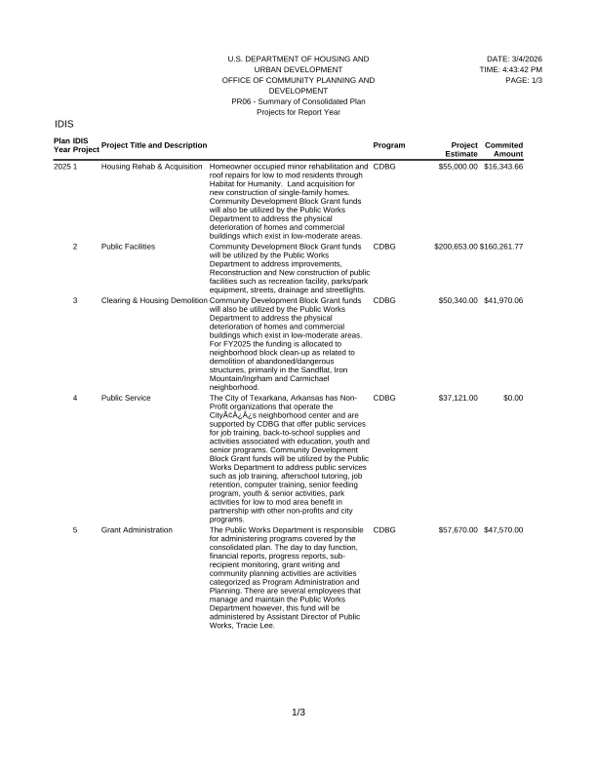
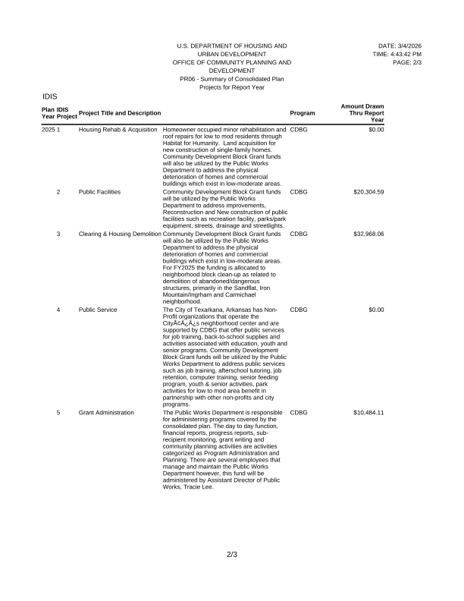
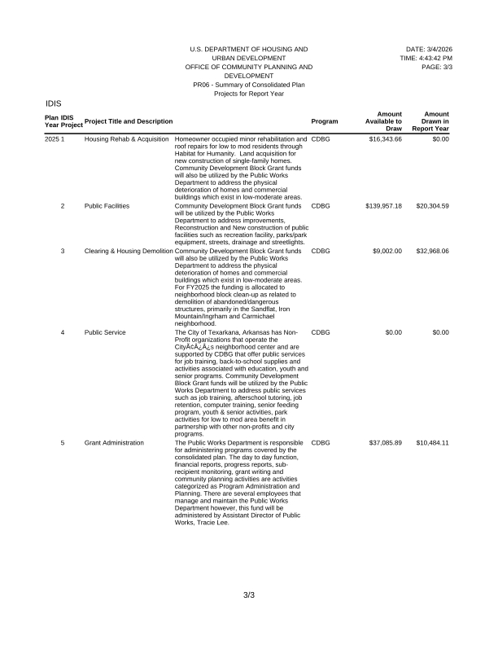
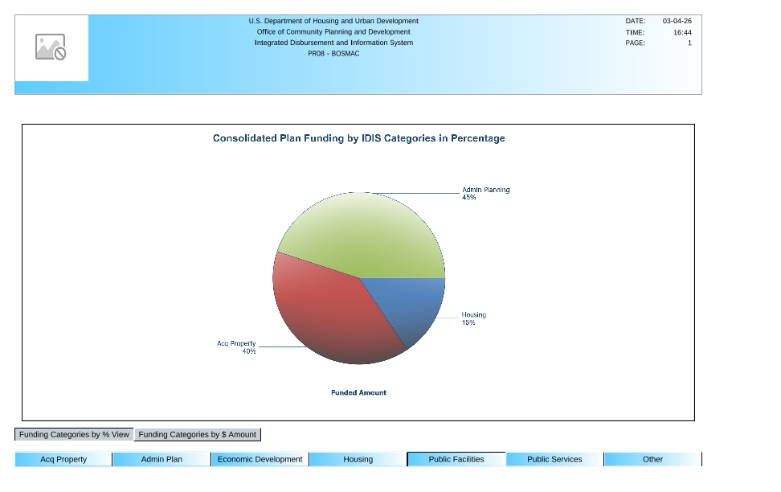
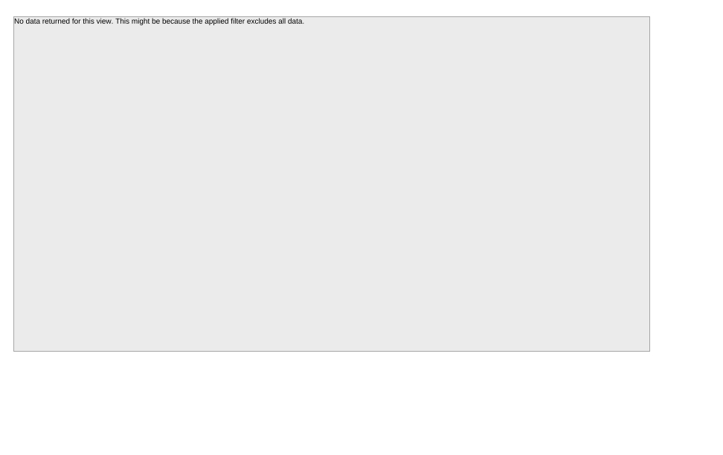

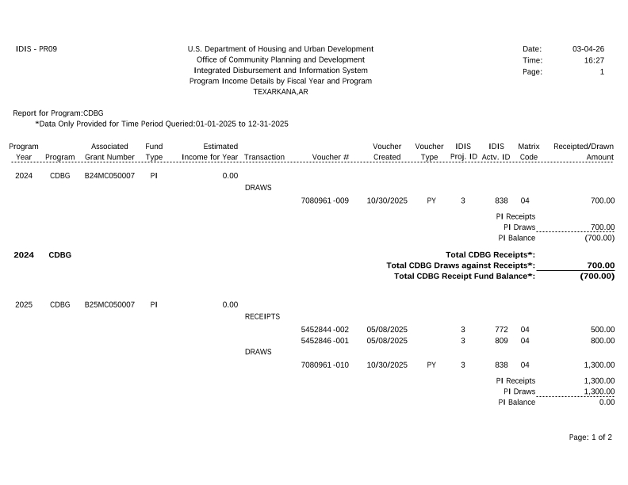
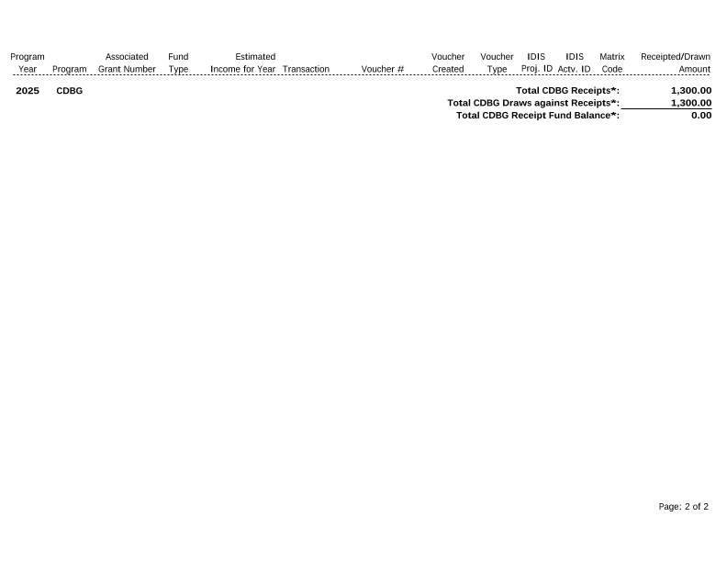
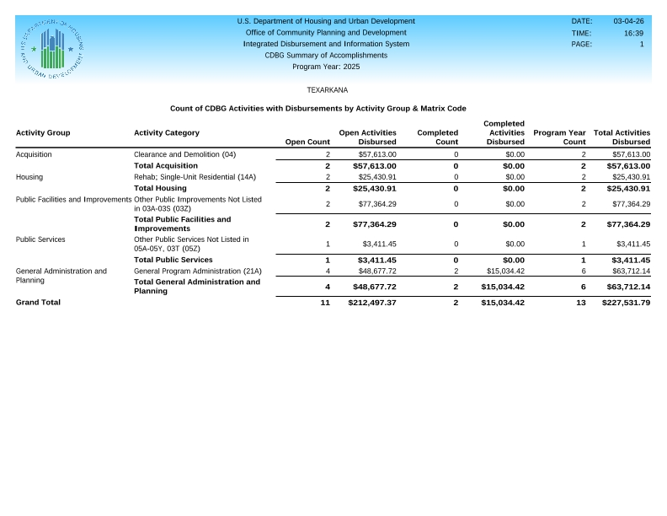
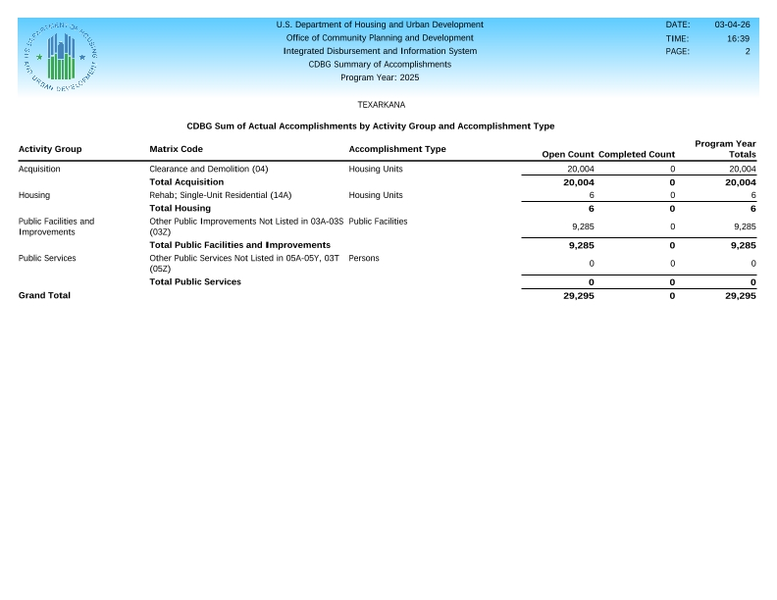
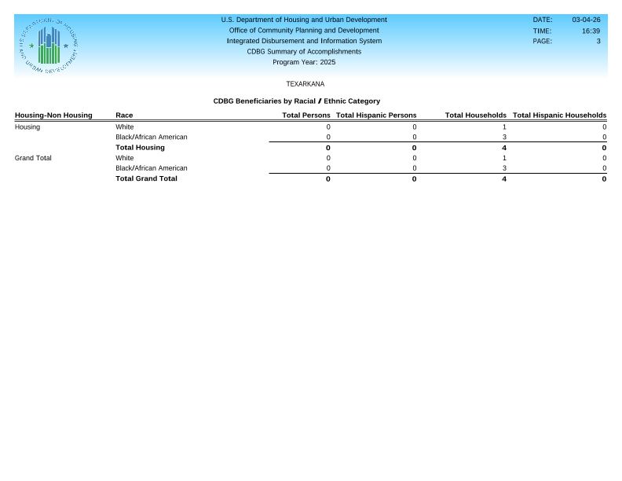
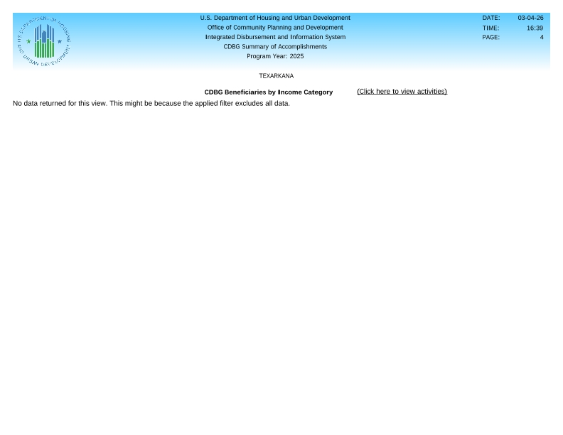
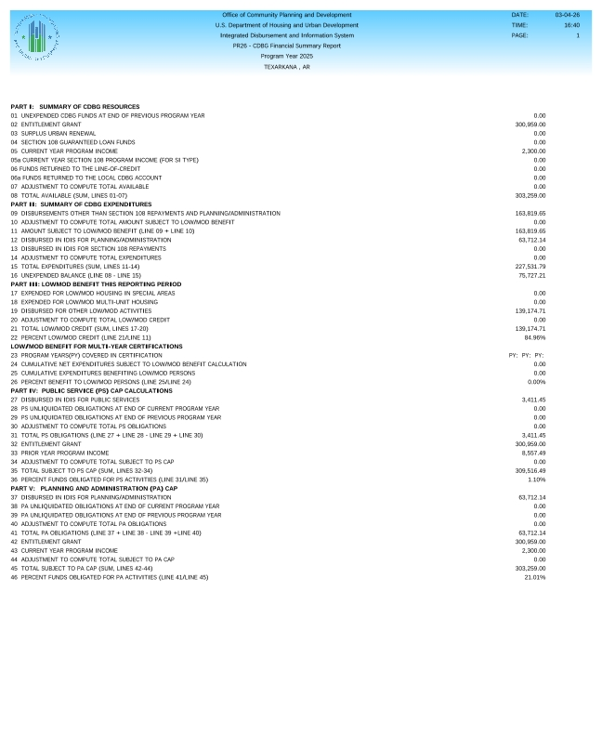
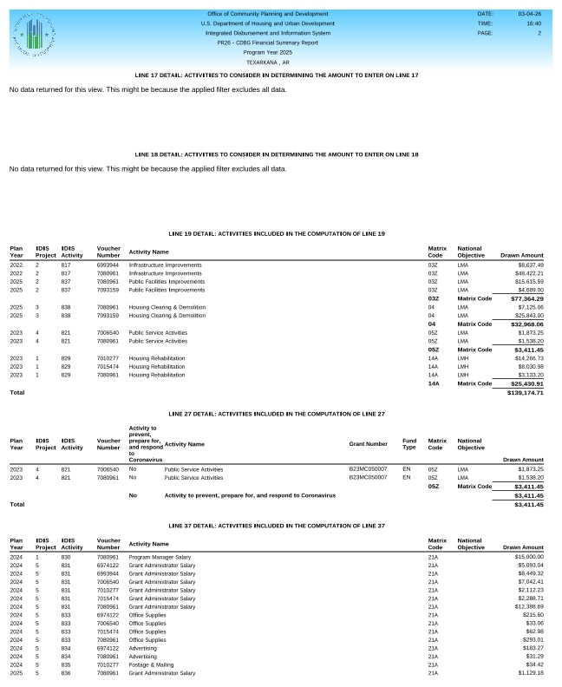

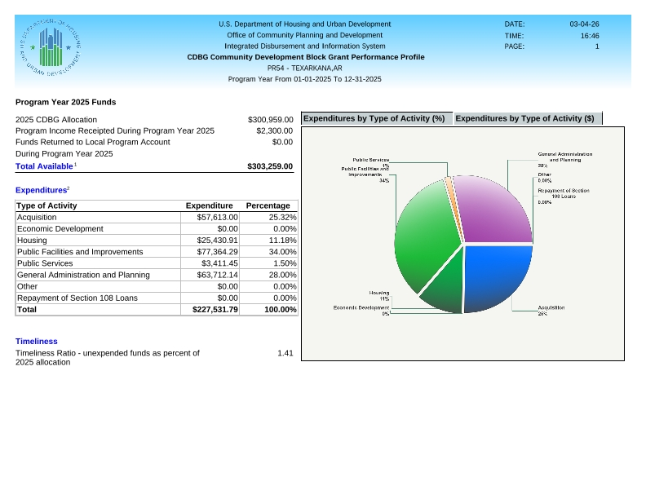
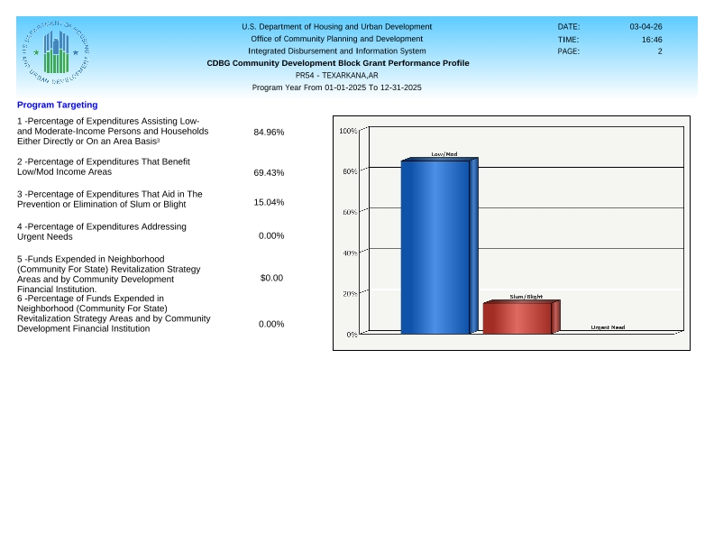
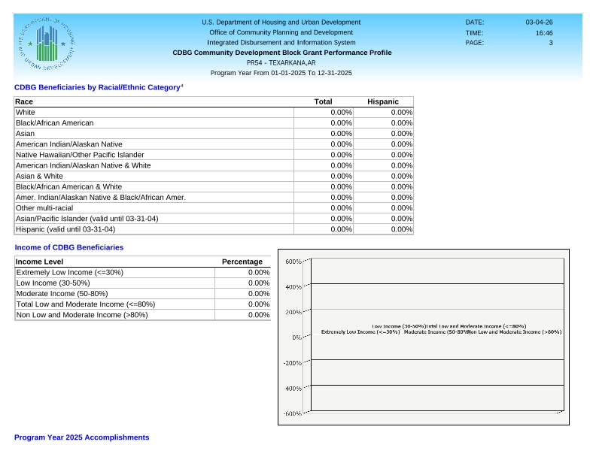
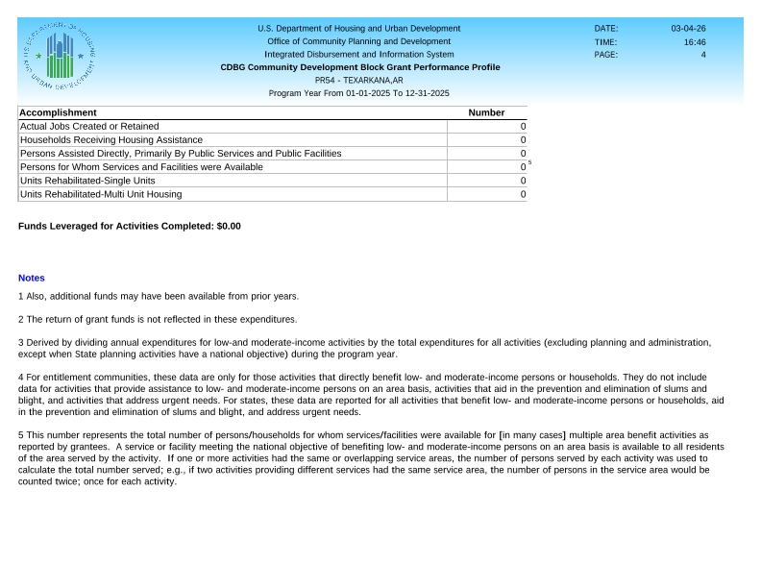
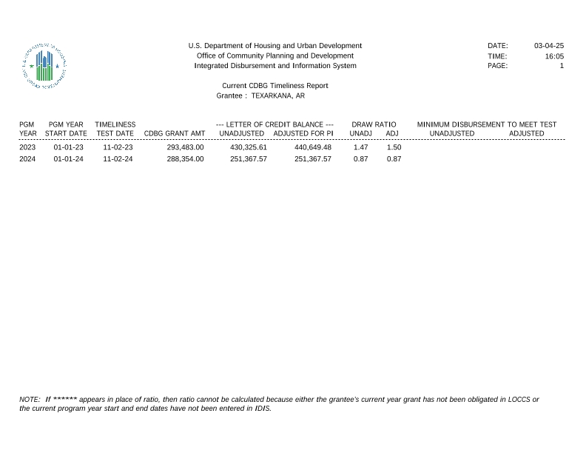

Public Notice for CAPER Review


